DAY-4:

**1.Find the Mean, Median and Mode of the array of numbers?**

def mean(a, n):  
 sum = 0  
 for i in range(n):  
 sum += a[i]  
 print("Mean =", sum / n)  
def mode(a, n):  
 max_count = 0  
 mode_value = None  
 for i in range(n):  
 count = 0  
 for j in range(i+1,n):  
 if a[i] == a[j]:  
 count += 1  
 if count > max_count:  
 max_count = count  
 mode_value = a[i]  
 print("Mode =", mode_value)  
def median(a,n):  
 a.sort()  
 if n%2==0:  
 mid=n//2  
 media=(a[mid]+a[mid+1])/2  
 else:  
 mid=n//2  
 media=a[mid]  
 print("median=",media)  
  
n = int(input("Enter the number of elements: "))  
a = []  
print("Enter the elements: ")  
for i in range(n):  
 b = int(input())  
 a.append(b)  
  
mean(a, n)  
mode(a, n)  
median(a,n)

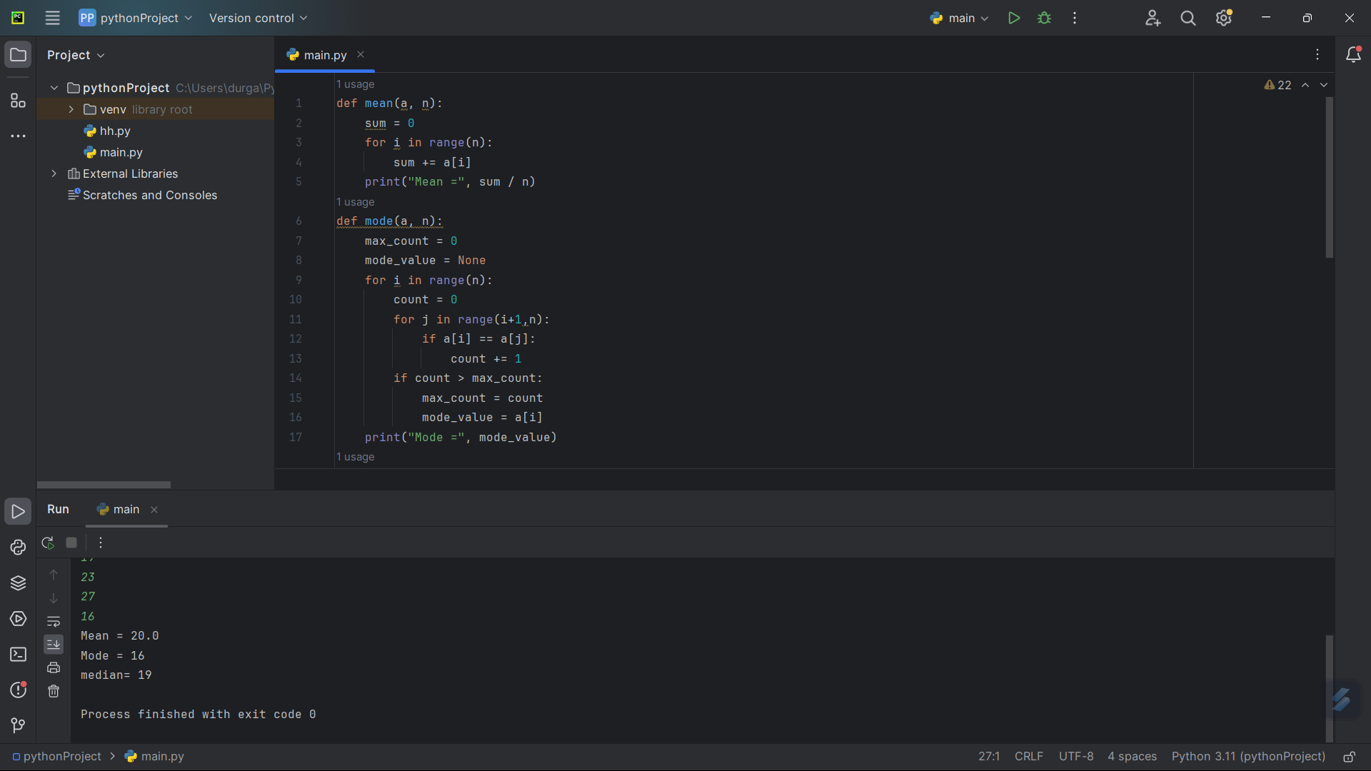

2. **Write a program to find the number of student users in the college, get the total users, staff**

**users’ detail from the client. Note for every 3 staff user there is one non-teaching staff user**

**assigned by default.**

t=int(input("enter the total number of users: "))  
s=int(input("enter the number of staff users: "))  
ns=s//3  
students=t-s-ns  
print("total number of student users :",students)

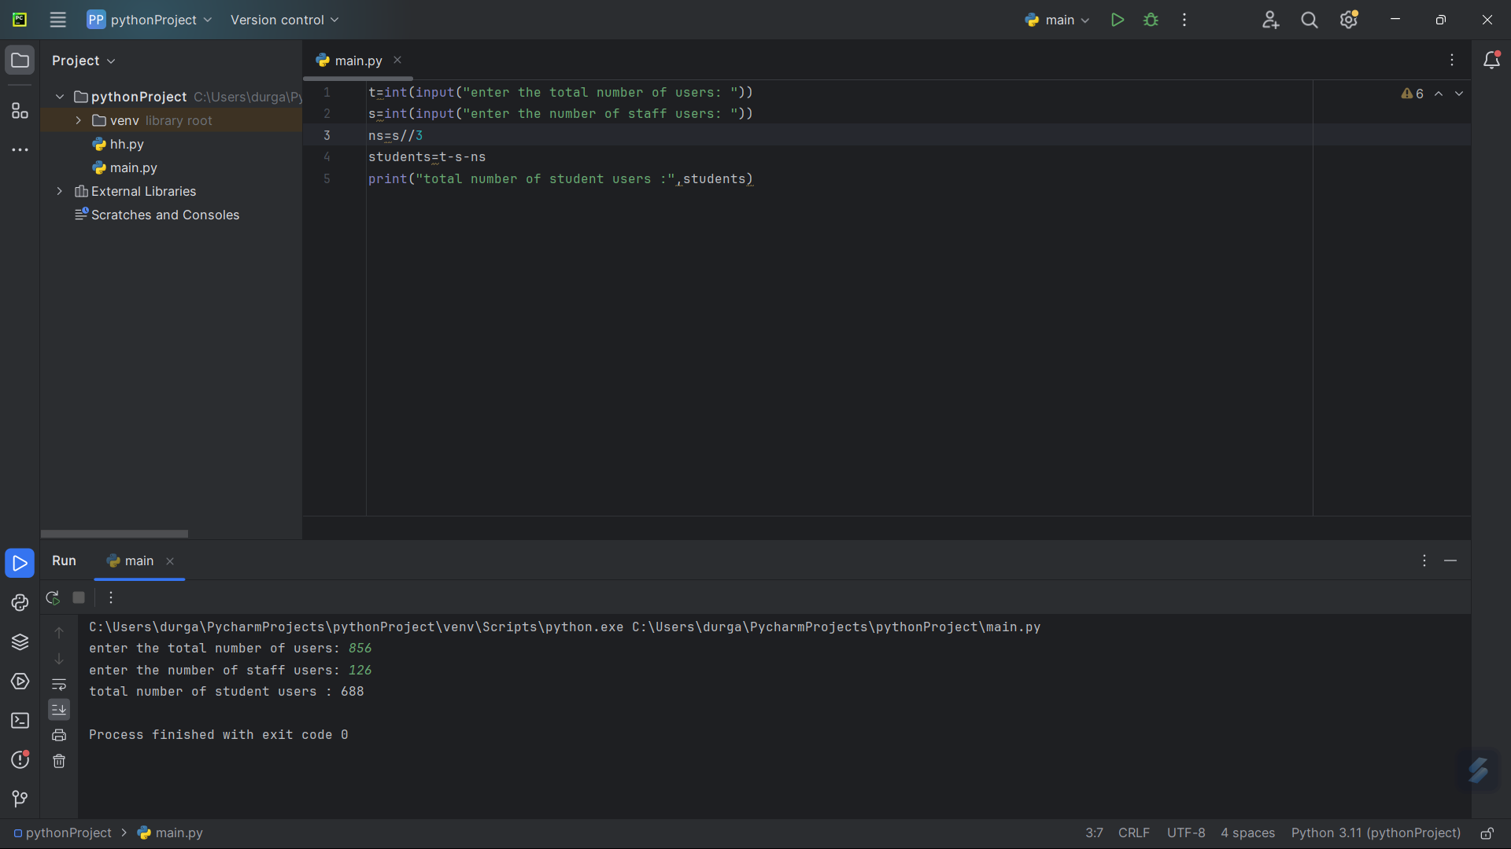

3. **Find the year of the given date is leap year or not**

year=input("enter the year(dd/mm//yyyy):")  
a=year.split("/")  
y=int(a[-1])  
if (y%400==0) or(y%100!=0 and y%4==0):  
 print("leap year")  
else:  
 print("not a leap year")

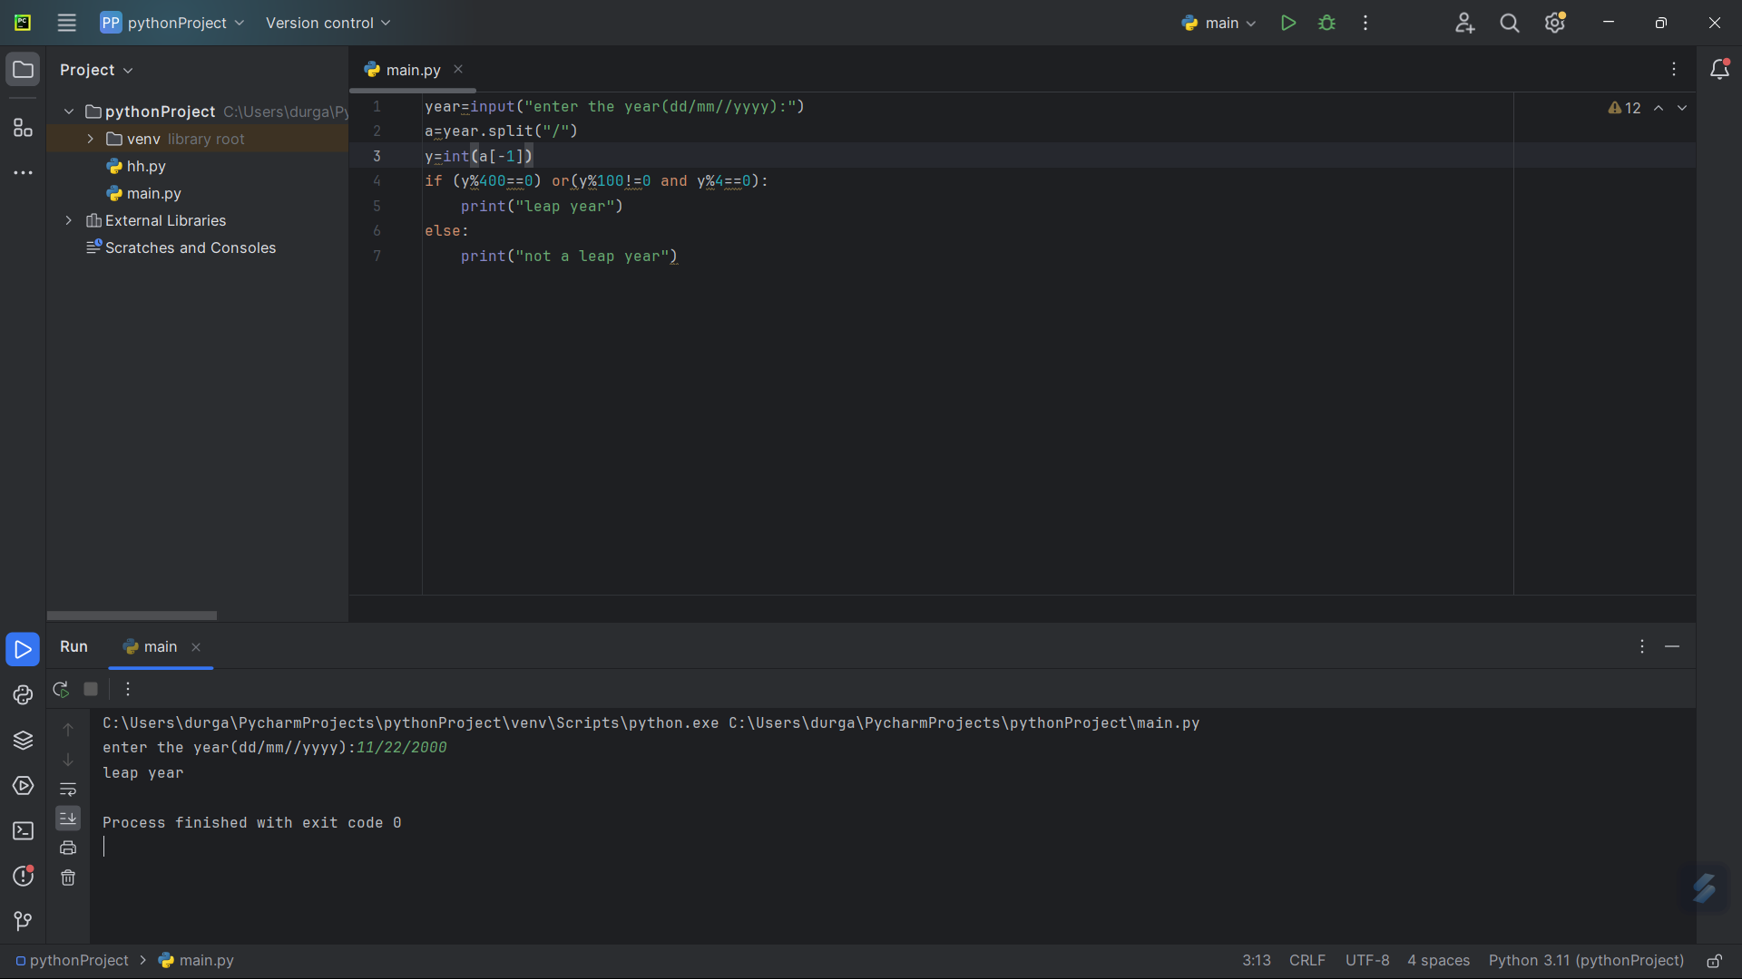

4. **Write a program to print the special characters separately and print number of Special characters in the line?**

**special_characters = "!@#$%^&*()-+?_=,<>/ "  
count = 0  
s = input("Enter the string: ")  
for char in s:  
 if char in special_characters:  
 count += 1  
 print(char,end=" ")  
print("\nNumber of special characters:", count)**

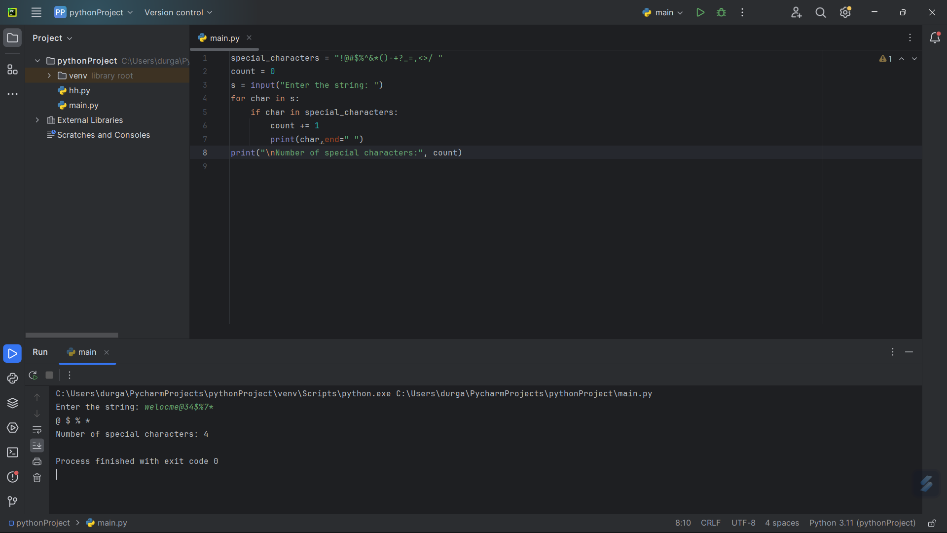

5. **Write a program to enter the marks of a student in four subjects. Then calculate the total and aggregate, display the grade obtained by the student. If the student scores an aggregate greater than 75%, then the grade is Distinction. If aggregate is 60>= and <75, then the grade is First Division. If aggregate is 50 >= and <60, then the grade is Second Division. If aggregate is 40>= and <50, then the grade is Third Division. Else the grade is Fail.**

n=int(input("enter the number of subjects: "))  
i=1  
sum=0  
while i < n+1:  
 m=int(input("enter the marks in subject "))  
 sum+=m  
 i+=1  
print("Total marks secured:",sum)  
Aggregate = (sum / (n * 100)) * 100  
print(Aggregate)  
if Aggregate>=75:  
 print("Distinction")  
elif Aggregate>=60 and Aggregate<75 :  
 print("First Division")  
elif Aggregate>=50 and Aggregate<60:  
 print("Second Division")  
elif Aggregate>=40 and Aggregate<50:  
 print("Third Division")  
else:  
 print("Fail")

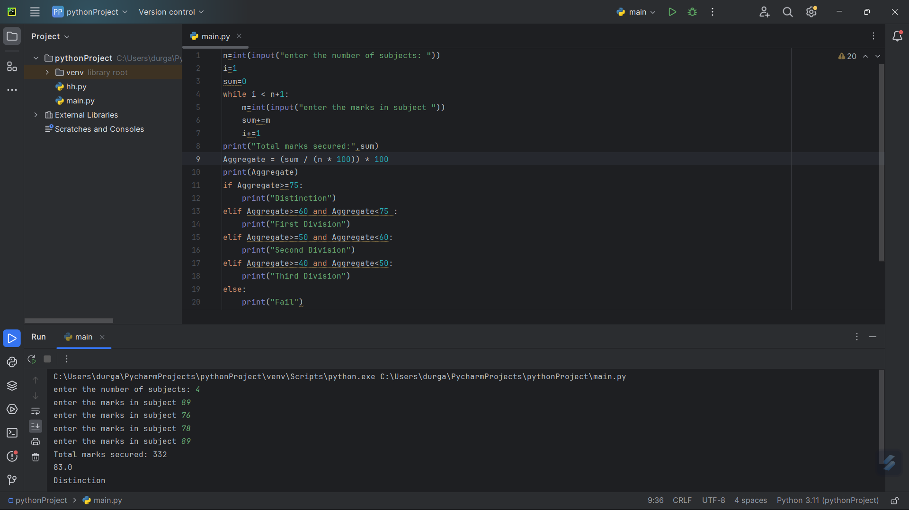

6. **Write a program to calculate the factorial of number using recursive function.**

def factorial(n):  
 if n == 0 or n == 1:  
 return 1  
 else:  
 return n * factorial(n - 1)  
n = int(input("Enter the number: "))  
print("Factorial of", n, "=", factorial(n))

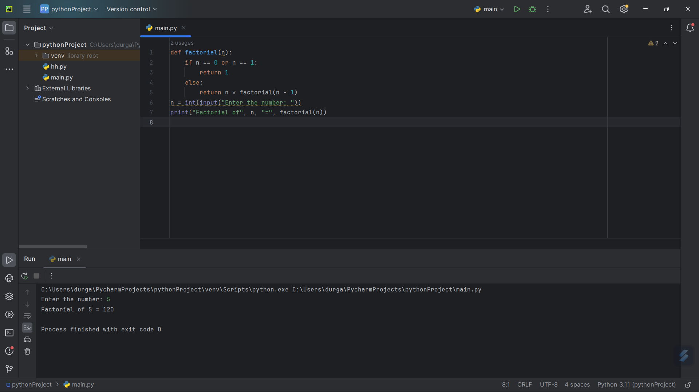

7. **Python Program to Find the Nth Largest Number in a List**

n=int(input("enter the number of elements: "))  
a=[]  
print("enter the elements: ")  
for i in range(1,n+1):  
 b=int(input())  
 a.append(b)  
a.sort(reverse=True)  
l=int(input("enter the nth position: "))  
print(l," largest number: ",a[l-1])

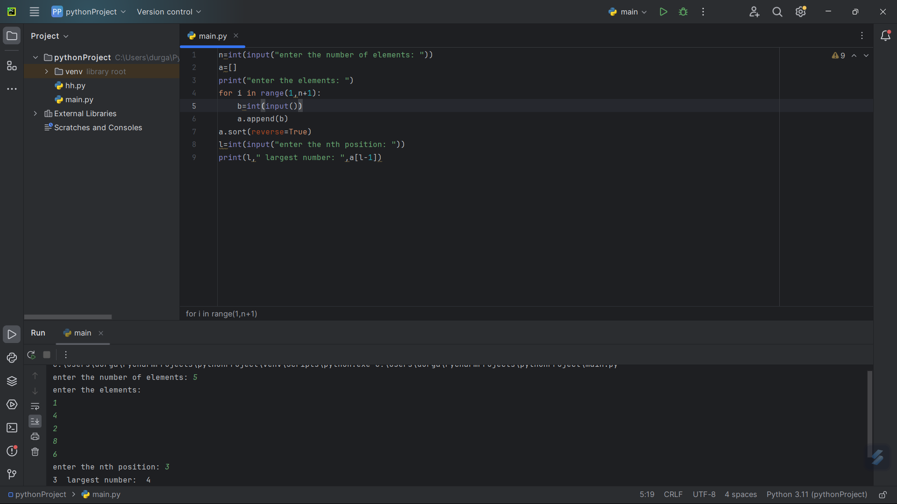

8. **Write a Python Program to remove duplicates numbers entirely from the sorted array**

n = int(input("Enter the size of the array: "))  
a = []  
print("Enter the array: ")  
for i in range(n):  
 b = int(input())  
 a.append(b)  
for i in range(n):  
 for j in range(i + 1, n):  
 if a[i] == a[j]:  
 for k in range(j, n - 1):  
 a[k] = a[k + 1]  
 n -= 1  
print("Array with duplicates removed:")  
for i in range(n):  
 print(a[i], end=" ")

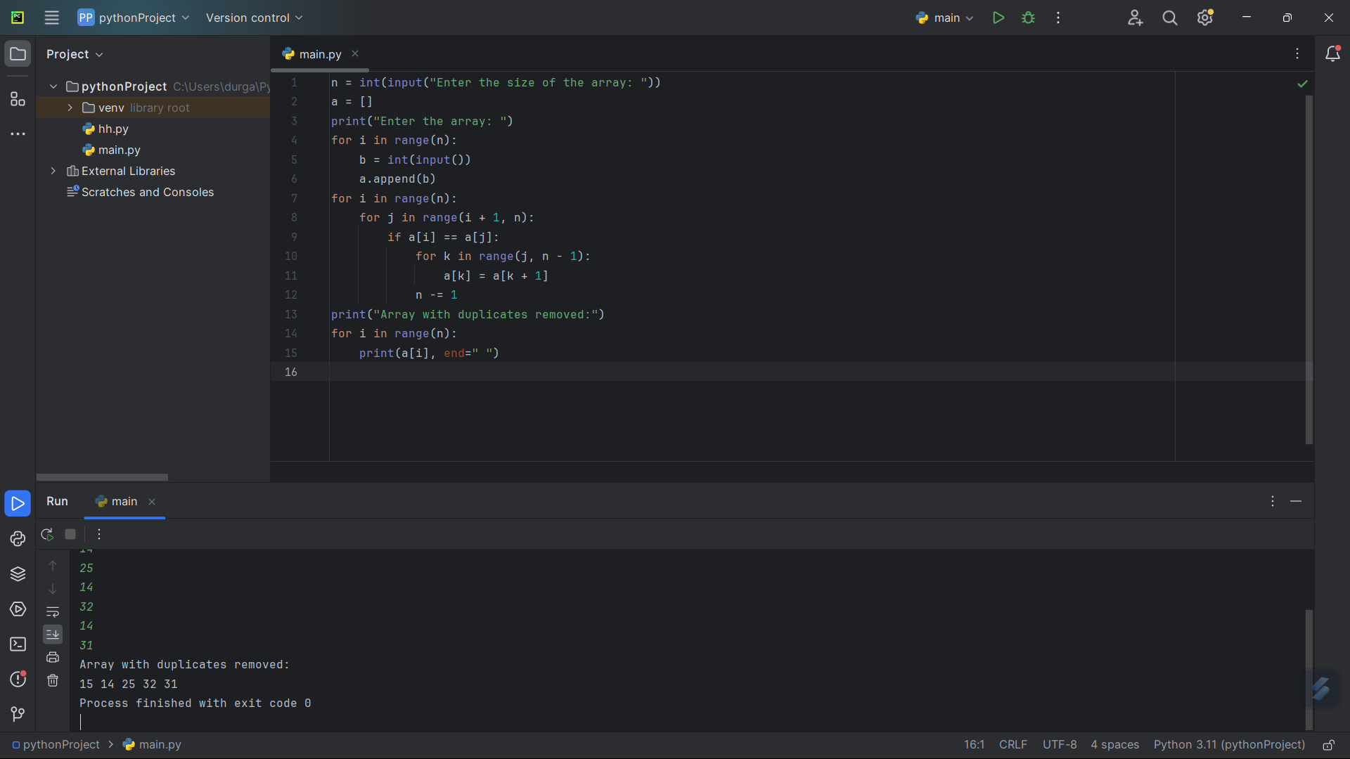

9. **Write a program to merge two sorted lists to the third list.**

str1=input("enter the elements in array 1 :")  
str2=input("enter the elements in array 2 :" )  
str3=str1+str2  
print(str3,end=" ")

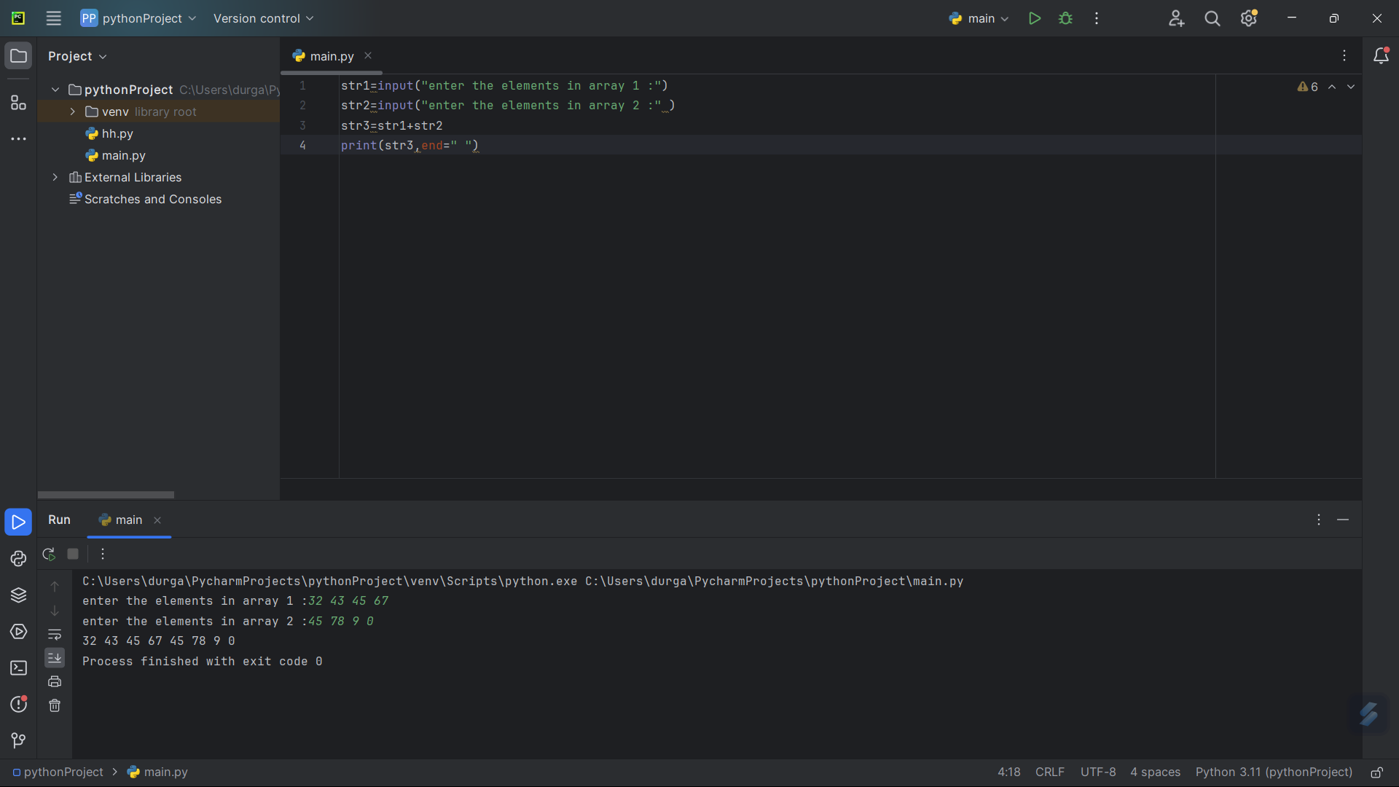

10. **Find the Mth maximum number and Nth minimum number in an array and then find the sum of it and difference of it.**

n=int(input("enter the number of elements: "))  
a=[]  
print("enter the elements: ")  
for i in range(1,n+1):  
 b=int(input())  
 a.append(b)  
a.sort(reverse=True)  
l=int(input("enter the mth position: "))  
x=a[l-1]  
print(l," maximum number: ",x)  
a.sort()  
s=int(input("enter the nth position: "))  
y=a[s-1]  
print(s," smallest number ",y)  
sum=x+y  
difference=x-y  
print("sum=",sum)  
print("difference=",difference)

